Lesson 11: The Graph of a Function

Classwork

In Module 1, you graphed equations such as $y=10-4x$ by plotting the points in the Cartesian plane by picking $x$  
-values and then using the equation to find the $y$-value for each $x$-value. The number of ordered pairs you plotted to get the general shape of the graph depended on the type of equation (linear, quadratic, etc.). The graph of the equation was then a representation of the solution set, which could be described using set notation.

In this lesson, we extend set notation slightly to describe the graph of a function. In doing so, we explain a way to think about set notation for the graph of a function that mimics the instructions a tablet or laptop might perform to draw a graph on its screen.

**Exploratory Challenge 1**

Computer programs are essentially instructions to computers on what to do when the user (you!) makes a request. For example, when you type a letter on your smart phone, the smart phone follows a specified set of instructions to draw that letter on the screen and record it in memory (as part of an email, for example). One of the simplest types of instructions a computer can perform is a *for-next loop*. Below is code for a program that prints the first $5$ powers of $2$:

|  |
| --- |
| Declare $x$ integer For all $x$ from 1 to 5  Print $2^{x}$ Next $x$ |

The output of this program code is

$$2 \\ 4 \\ 8 \\ 16 \\ 32$$

Here is a description of the instructions: First, $x$ is quantified as an integer, which means the variable can only take on integer values and cannot take on values like $\frac{1}{3}$ or $\sqrt{2}$. The *For* statement begins the loop, starting with $x=1$. The instructions between *For* and *Next* are performed for the value $x=1$, which in this case is just to *Print $2$* . (Print means “print to the computer screen.”) Then the computer performs the instructions again for the next $x$ ($x=2$), that is,   
*Print $4$* , and so on until the computer performs the instructions for $x=5$, that is, *Print $32$* .

Exercise 1

Perform the instructions in the following programming code as if you were a computer and your paper was the computer screen.

|  |
| --- |
| Declare $x$ integer For all $x$ from 2 to 8  Print $2x+3$ Next $x$ |

**Exploratory Challenge 2**

We can use almost the same code to build a set: First, we start with a set with zero elements in it (called the *empty set*), and then we increase the size of the set by appending one new element to it in each for-next step.

|  |
| --- |
| Declare $x$ integer Initialize $G$ as {} For all $x$ from $2$ to $8$  Append $2x+3$ to $G$  Print $G$ Next $x$ |

Note that $G$ is printed to the screen after each new number is appended. Thus, the output shows how the set builds:

$$\{7\} \\ \{7, 9\} \\ \{7, 9, 11\} \\ \{7, 9, 11, 13\} \\ \{7, 9, 11, 13, 15\} \\ \{7, 9, 11, 13, 15, 17\}$$ $\{7, 9, 11, 13, 15, 17, 19\}$.

Exercise 2

We can also build a set by appending ordered pairs. Perform the instructions in the following programming code as if you were a computer and your paper were the computer screen (the first few are done for you).

|  |
| --- |
| Declare $x$ integer Initialize $G$ as {} For all $x$ from $2$ to $8$  Append $(x,2x+3)$ to $G$ Next $x$ Print $G$ |

Output:  
{$(2,7)$, $(3,9)$, ________________________________________}

**Exploratory Challenge 3**

Instead of Printing the set $G$ to the screen, we can use another command, *Plot*, to plot the points on a Cartesian plane.

|  |
| --- |
| Declare $x$ integer Initialize $G$ as {} For all $x$ from $2$ to $8$  Append $(x,2x+3)$ to $G$ Next $x$ Plot $G$ |

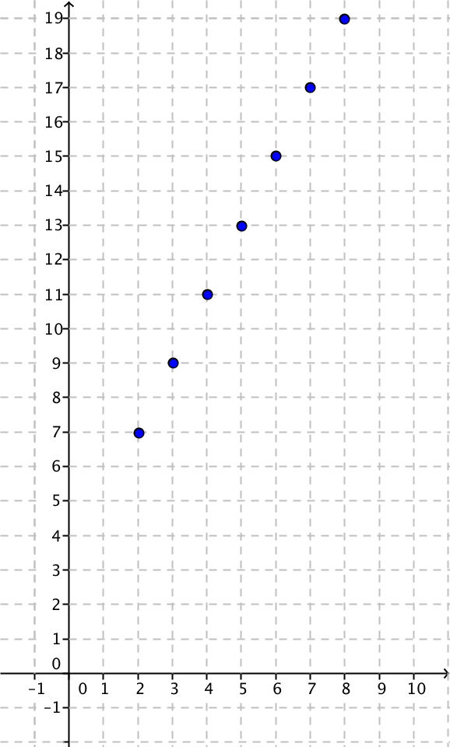Output:

In mathematics, the programming code above can be compactly written using set notation, as follows:

$$\left\{\left(x,2x+3\right) \right| x integer and 2≤x≤8\}.$$

This set notation is an abbreviation for “The set of all points $(x,2x+3)$ such that $x$ is an integer and $2≤x≤8$.” Notice how the set of ordered pairs generated by the for-next code above,

$$\left\{\left(2,7\right),\left(3,9\right), \left(4,11\right), \left(5,13\right), \left(6,15\right), \left(7,17\right), \left(8,19\right)\right\},$$

also satisfies the requirements described by $\left\{\left(x,2x+3\right) \right| x integer, 2≤x≤8\}$. It is for this reason that the set notation of the form

$$\{type of element | condition on each element\}$$

is sometimes called *set-builder notation*—because it can be thought of as building the set just like the for-next code.

Discussion

We can now upgrade our notion of a for-next loop by doing a thought experiment: Imagine a for-next loop that steps through *all* real numbers in an interval (not just the integers). No computer can actually do this—computers can only do a finite number of calculations. But our human brains are far superior to that of any computer, and we can easily imagine what that might look like. Here is some sample code:

|  |
| --- |
| Declare $x$ real Let $f\left(x\right)=2x+3$ Initialize $G$ as {} For all $x$ such that $2≤x≤8$  Append $\left(x,f\left(x\right)\right)$ to $G$ Next $x$ Plot $G$ |

The output of this thought code is the graph of $f$ for all real numbers $x$ in the interval $2≤x≤8$:

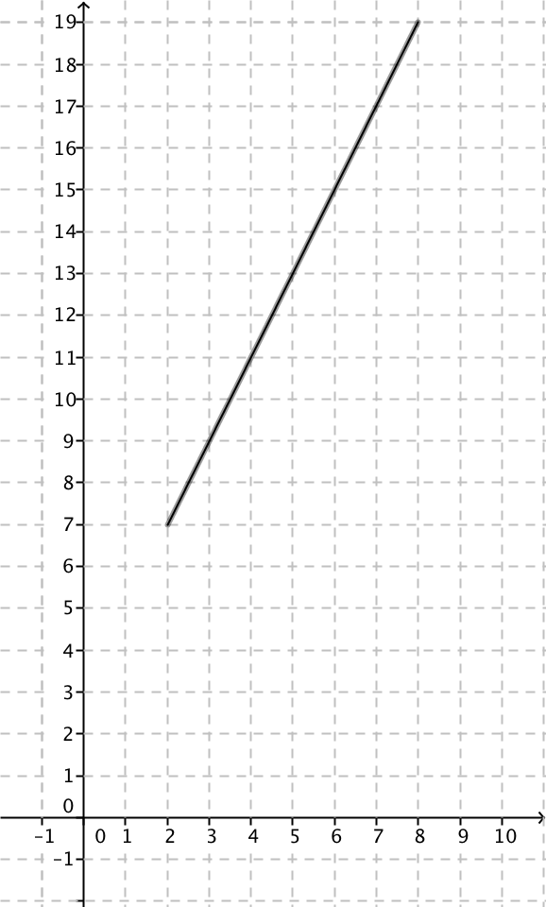

Exercise 3

* 1. Plot the function $f$ on the Cartesian plane using the following for-next thought code.

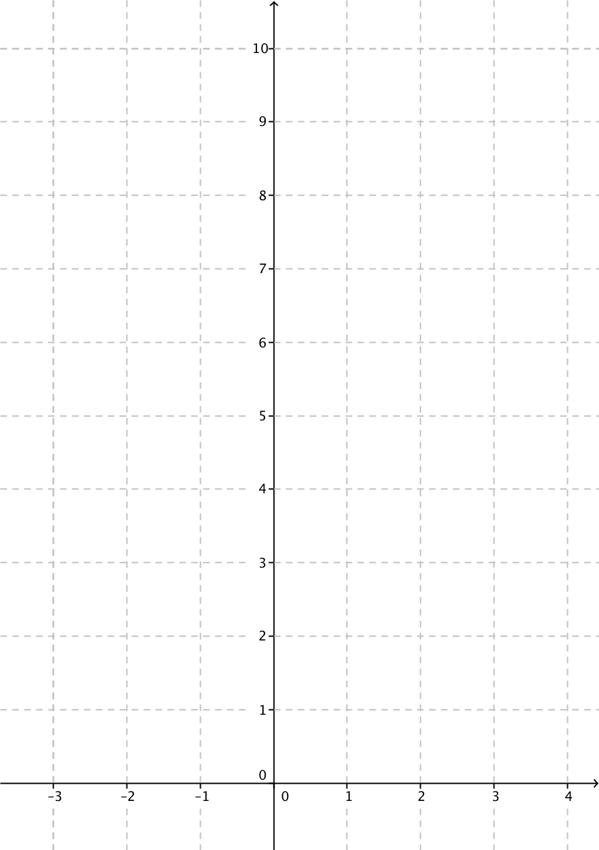

|  |
| --- |
| Declare $x$ real Let $f\left(x\right)=x^{2}+1$ Initialize $G$ as {} For all $x$ such that $-2≤x≤3$  Append $\left(x,f\left(x\right)\right)$ to $G$ Next  Plot |

* 1. For each step of the for-next loop, what is the input value?
  2. For each step of the for-next loop, what is the output value?
  3. What is the domain of the function $f$?
  4. What is the range of the function $f$?

Closing

The set $G$ built from the for-next thought code in Exercise 4 can also be compactly written in mathematics using set notation:

$$\left\{\left(x,x^{2}+1\right) \right| x real, -2≤x≤3\}.$$

When this set is thought of as plotted in the Cartesian plane, it is the same graph. When you see this set notation in the Problem Set and/or future studies, it is helpful to imagine this set-builder notation as describing a for-next loop.

In general, if $f:D→Y$ is a function with domain $D$, then its *graph* is the set of all ordered pairs,

$$\left\{\left(x,f\left(x\right)\right) \right| x∈D\},$$

thought of as a geometric figure in the Cartesian coordinate plane. (The symbol $∈$ simply means “in.” The statement $x∈D$ 
 is read, “ $x$ in $D$.”)

Problem Set

1. Perform the instructions for each of the following programming codes as if you were a computer and your paper was the computer screen.

|  |
| --- |
| **Declare $x$ integer For all $x$ from $0$ to $4$  Print $2x$ Next $x$** |

Lesson Summary

**Graph of $f$:** Given a function $f$ whose domain $D$ and range are subsets of the real numbers, the graph of $f$ is the set of ordered pairs in the Cartesian plane given by $$\left\{\left(x,f\left(x\right)\right) \right| x∈D\}.$$

|  |
| --- |
| **Declare $x$ integer For all $x$ from $0$ to $10$  Print $2x+1$ Next** |

|  |
| --- |
| **Declare $x$ integer For all $x$ from $2$ to $8$  Print $x^{2}$ Next** |

|  |
| --- |
| **Declare $x$ integer For all $x$ from $0$ to $4$  Print ${10∙3}^{x}$ Next $x$** |

1. Perform the instructions for each of the following programming codes as if you were a computer and your paper were the computer screen.

|  |
| --- |
| **Declare $x$ integer Let $f\left(x\right)=\left(x+1\right)\left(x-1\right)-x^{2}$ Initialize $G$ as {} For all $x$ from $-3$ to $3$  Append $\left(x,f\left(x\right)\right)$ to $G$ Next $x$ Plot** |

|  |
| --- |
| **Declare $x$ integer Let $f\left(x\right)=3^{-x}$ Initialize $G$ as {} For all $x$ from $-3$ to $3$  Append $\left(x,f\left(x\right)\right)$ to $G$ Next $x$ Plot** |

|  |
| --- |
| **Declare $x$ real Let $f\left(x\right)=x^{3}$ Initialize $G$ as {} For all $x$ such that $-2≤x≤2$  Append $\left(x,f\left(x\right)\right)$ to $G$ Next $x$ Plot $G$** |

1. Answer the following questions about the thought code:

|  |
| --- |
| **Declare $x$ real Let $f\left(x\right)=(x-2)(x-4)$ Initialize $G$ as {} For all $x$ such that $0≤x≤5$  Append $\left(x,f\left(x\right)\right)$ to $G$ Next  Plot** |

* 1. What is the domain of the function $f$?
  2. Plot the graph of $f$ according to the instructions in the thought code.
  3. Look at your graph of $f$. What is the range of $f$?
  4. Write three or four sentences describing in words how the thought code works.

1. Sketch the graph of the functions defined by the following formulas, and write the graph of $f$ as a set using set-builder notation. (Hint: Assume the domain is all real numbers unless specified in the problem.)
 $f\left(x\right)=x+2$

 $f\left(x\right)=3x+2$

 $f\left(x\right)=3x-2$

$f\left(x\right)=-3x-2$

$f\left(x\right)=-3x+2$

$f\left(x\right)=-\frac{1}{3}x+2$ 1. , $-3≤x≤3$
   2. $f\left(x\right)={\left(x+1\right)}^{2}-x^{2}$, $-2≤x≤5$
   3. $f\left(x\right)={\left(x+1\right)}^{2}-{\left(x-1\right)}^{2}$, $-2≤x≤4$
2. The figure shows the graph of .

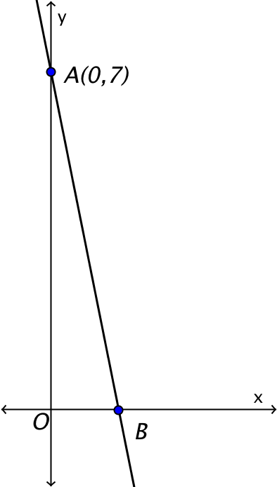

* 1. Find the value of $c$.
  2. If the graph of $f$ intersects the $x$-axis at $B$, find the coordinates of $B$.

1. The figure shows the graph of .

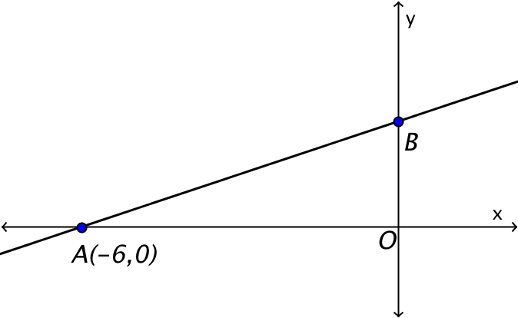

* 1. Find the value of $c$.
  2. If the graph of $f$ intersects the $y$-axis at $B$, find the coordinates of $B$.
  3. Find the area of triangle $AOB$.